Title: Use your imagination, plant a Perma garden

Author: Dunja Milenković

Mentor: Valentina Aščetović

Translation: Marija Jelenić

Lecturer: Dragoslava Stamenković

Information: Danijela Milić

Elementary school "Toplički heroji" Žitorađa, Serbia

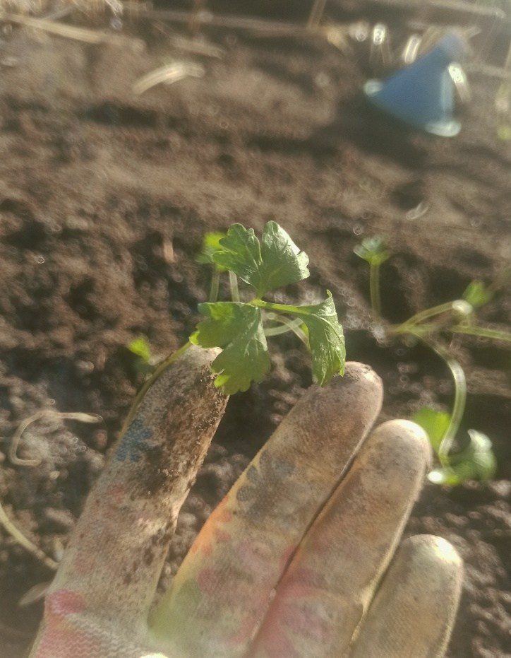
Introduction: People are consumers, and in order to support this need, various sources of energy are needed. Due to the increase of carbon dioxide and methane in the atmosphere, the greenhouse effect is created, which contributes to global warming. One of the best solutions for environmental protection is Permaculture, which transforms agricultural systems into ecosystems. Its goal is to maintain a harmonious relationship between people, plants and animals. Perma gardens mimic ecosystems, support biodiversity, reduce soil erosion, strive for self-sustainability and reduce the use of harmful chemicals.

Main information: Perma gardens consist of 5 layers: substrate, compost, hay,soil and plants. Also, it is necessary to make a frame as small as possible from wooden slats, where the garden will be planted. We were monitoring our Perma garden through two seasons. During the first season the garden produced onions and potatoes that grew faster than in a regular garden.
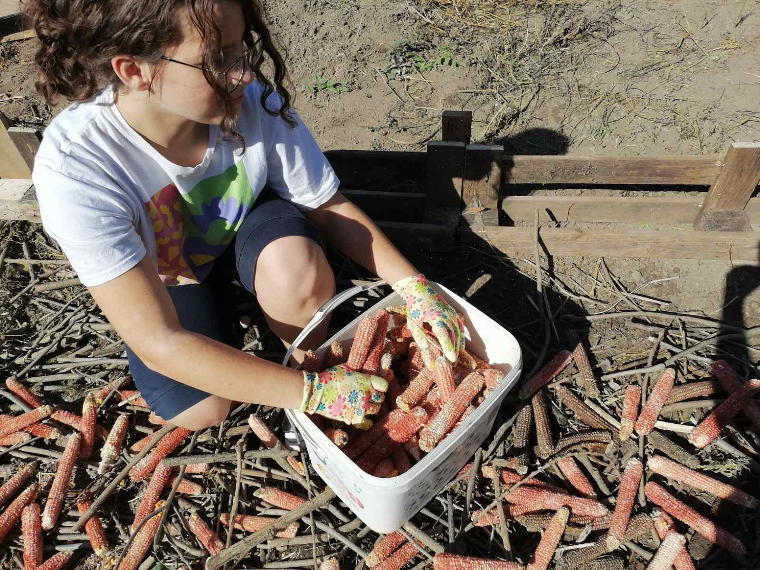
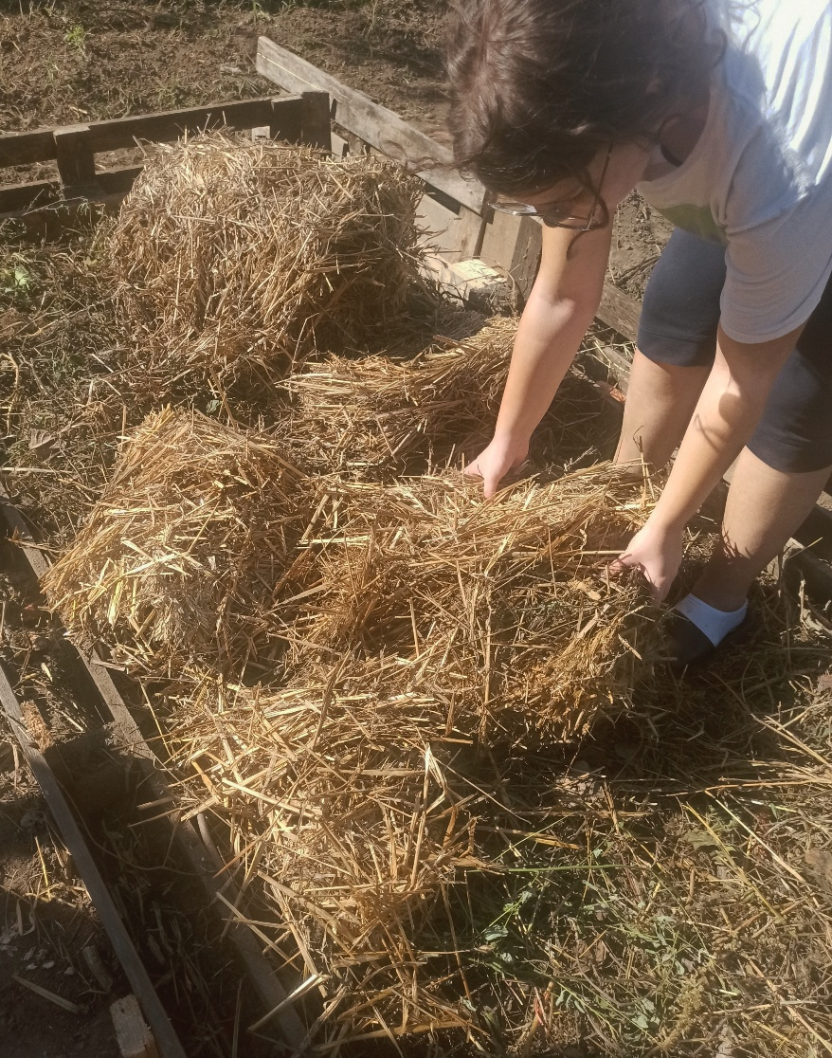
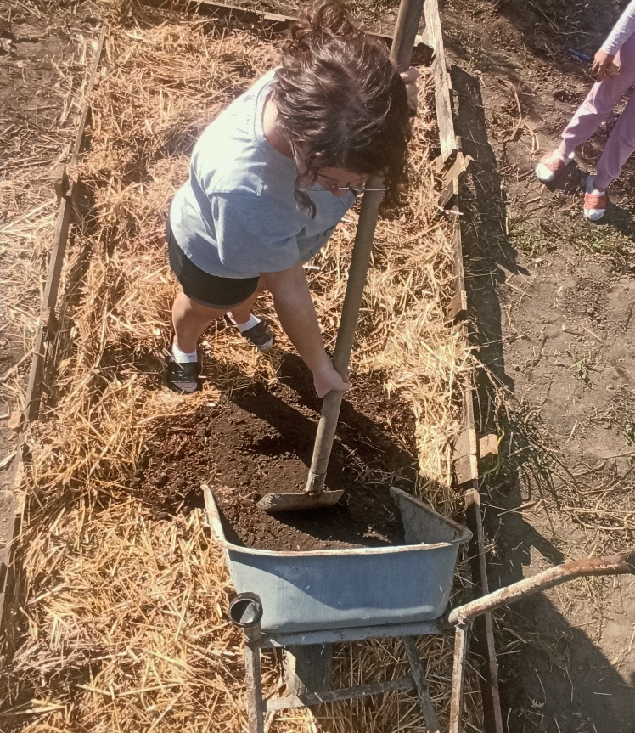
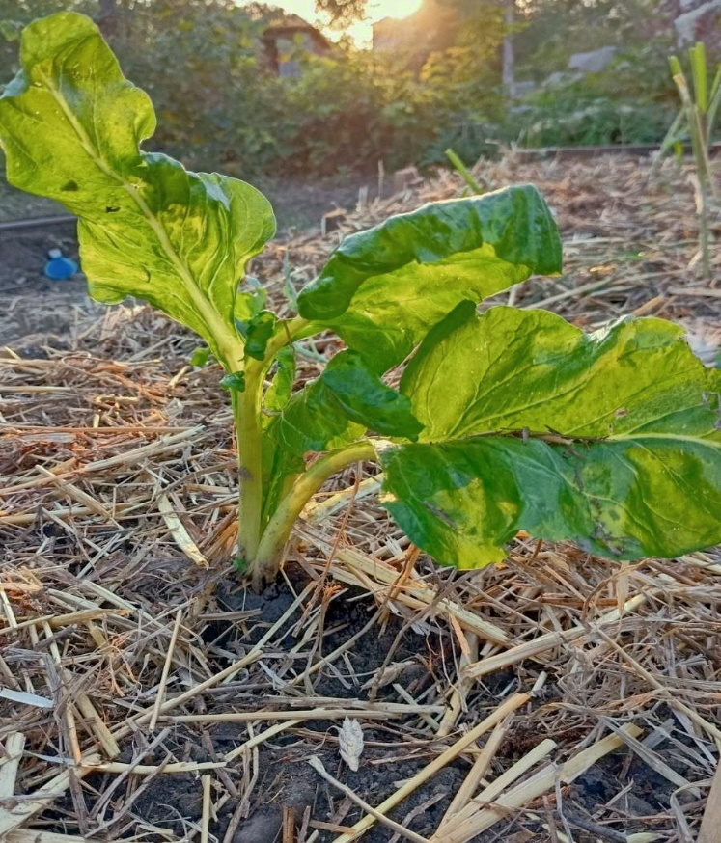
During the second season, we planted onions, cucumbers, parsley, peppers, chard, corn and cabbage. At the same time, we were monitoring the growth of classic gardens, so we noticed that ,in our Perma gardens ,the fruits were ripen earlier and they were of much better quality. Weeds, grass and flowers, that had naturally settled in our the gardens, prevented unwanted insects from destroying the fruits.
Its substrate moisture and the contact with the damaged soil. Due to the layer of hay and natural compost, the soil received the necessary microorganisms and food that supported the plants. The plants buried the ir roots in the mixture of soil and natural fertilizer. The fruits were of high quality and much healthier than the same ones that w ere produced with the help of Agriculture which is spread all around the world.

Key points: A perma garden consists of layers of substrate, compost, hay, soil and
plants. Perma gardens create a community of people, plants and animals, support biodiversity, reduce soil erosion and the use of harmful chemicals. Perma gardens are the best for people, environment and economy.
Call to action: Although we cannot solve a global problem as individuals, we can
affect our environment. We work for nature and not against it! Let's plant a Perma garden!
Cooperation: Elementary school "Toplicki heroji" Žitoradja , local authorities

Contact: Primary School "Toplički heroji" gmail address: dunja10milenkovic@gmail.com v.ascetovic@hotamail.com instagram:@zasadi_perma_bastu, @milenkovicdunja1
Facebook:@Valentina Jovic Acsetovic
